Module 7 Discussion

Using the 100 Things Every Designer Should Know About People reading assignment, select two (2) of the "things" you read about, include the number and title of the "thing" (i.e., #36 Time is Relative) , and then do two embellishments, one embellishment and one visual example, or two visual examples.
- Embellish: Tell us something that the reading did not tell us on that specific "thing" or embellish on what was presented. Be sure you are adding meaningful content to the conversation and not just making noise. Your addition can be a link to an article, or you can write out your embellishment.
- Visual Example: Provide us with a graphic example that is relevant to web design. This can be something you create or something you find. Again, be sure to add meaningful content to the conversation.

Topic #57: People are Inherently Lazy
Embellishment:
The text discusses how we have evolved to become more efficient. We need to conserve our energy to get the things we need for survival (food, water, shelter, and procreation). But as our society evolved and many of those things no longer required the time and energy they once did, we have a lot of unaccounted-for time and energy on our hands. This means that, even though our base instincts to gravitate towards these 4 core needs are still there (as discussed in an earlier topic), we want more. But we are still trapped in the idea that we need to conserve our energy for these things, so we are constantly trying to conserve the energy and time we spend on things.
When designing for web applications or programming, it’s important to keep in mind that users will lose interest very quickly unless they need to be there. So, designing with the user’s efficiency in mind will make for happier users. The examples in the book show two sites: one jam-packed with information and the other simple, directing you where you need to go quickly. As a landing page, the second is MUCH simpler and more user-friendly, because it doesn’t force the user to read a bunch of information they don’t need to find out what they are looking for, whereas the Medicare site has a simple, well-named navigation menu to take you where you need to go. This makes the Medicare site friendlier and more user-friendly. The Appalachian website clearly has a lot of important information, but much of it will be lost to the user because most simply won’t read it.
Visual Example:
For a visual example, I give you this meme-ified quote from Bill Gates:
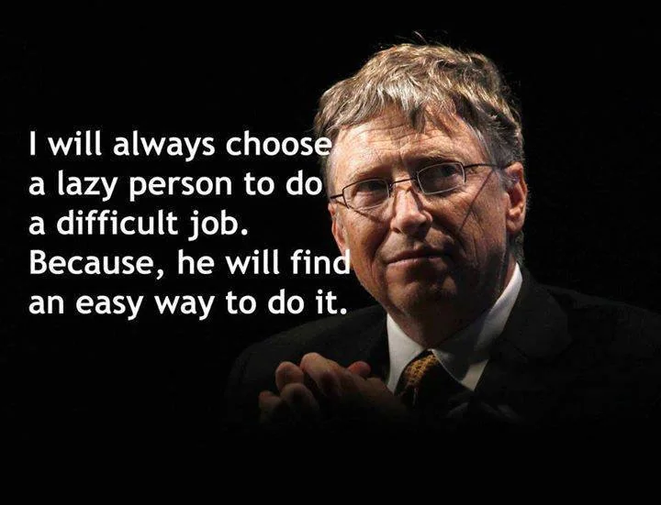

What Mr. Gates is saying here is that a lazy person is looking for the easy way to get something done. And the easy way CAN be more efficient. Naturally, you have to be wary of this because the easy (quick) way can also bypass security, safety, quality, and other concerns.

Topic #58: People Will Look for Shortcuts Only if the Shortcuts are Easy
Embellishment:
I believe in general this is probably true. The book talks about how the process of learning a new shortcut takes more time (at least in our minds) than it saves by using it (for example, learning that `Ctrl -` will delete a selected row or column in Excel when you can just select the delete column or row button on the ribbon at the top). However, I’m sure most of you (and almost all of you if you have kids), have heard the adage “People will work harder to get out of doing something than they would have to work to just do it!” I realize this isn’t exactly the same thing, but it’s very similar.
For example, my son HATES taking a shower. And he will sit in the bathroom with the shower running for 10 minutes… Put soap on his hands, neck, legs, and wipe it off (so he will smell like soap), get his hair wet, and then claim he showered. He doesn’t get his tablet or any other devices in the bathroom with him, but he still does this and tries to get away with it. Then he gets in trouble, has to shower for real, and he ended up spending MORE time and effort (even before having to get in the shower for real) than he would have if he had just done it. Of course, to him, the shortcut is avoiding him discomfort of having to shower. And sometimes that is what actually makes it seem easier.
Applying this to web and software design, users often look for workarounds when filling out forms they find unnecessary or tedious. Autocomplete, Password Managers, and the like are ways users try to avoid having to fill out common fields. Autocomplete only works if the fields are labeled correctly in the HTML! There are also ways to disable password managers, and that leads to user frustration as well.

